NYSSLS Daily Lesson Plan
Instructional Unit:  Weather and Climate –  Air masses, Fronts and Weather  LESSON - WEATHER VARIABLES AND FORECASTING ACCURACY |  |  |  |  | Period(s) of Unit:  1 PD + daily data weather forecast collection |  |  | Date:
Materials/Resources/Links:  Weather Reports to determine weather variables  http://www.youtube.com/watch?v=3clROfrVkPI  crazy wx man  http://www.youtube.com/watch?v=kpxiCxO5k0g  Wx channel  http://www.youtube.com/watch?v=12guXf5iHyo  Hurricane  https://www.youtube.com/watch?v=2qM72mBILP4  Wx map  http://www.usatoday.com/weather/fronts/latest-fronts-systems.htm  Present Weather Forecasts to collect weather data and determine the accuracy of weather forecasts  Weather Forecasting: How Predictable! - Activity - TeachEngineering  National and Local Weather Radar, Daily Forecast, Hurricane and information from The Weather Channel and weather.com  New York City Barometric Pressure Forecast and History |  |  |  |  |  |  |  | Course:  Earth and Space Science
Special Notes for Lesson:

ANCHORING PHENOMINON: How accurate are Weather forecasts and why. Teacher will give several examples where weather forecasts have been wrong. Students will investigate what a weather variable is and investigate the accuracy of weather forecasts over a 7 day period.

Standards:
Science and Engineering Practices  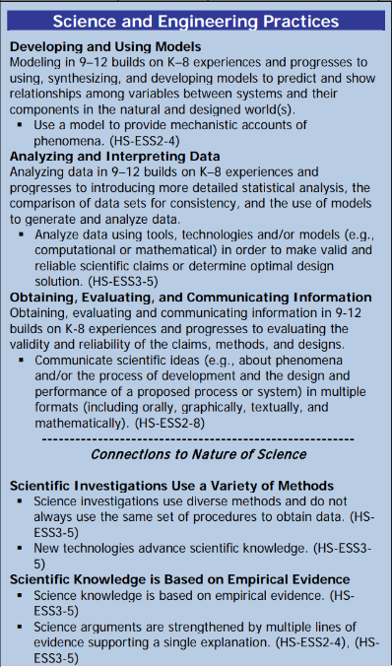 |  |  | Disciplinary Core Idea(s)  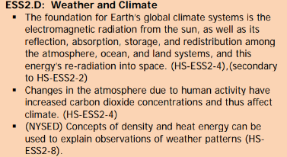 |  |  |  | Cross Cutting Concepts  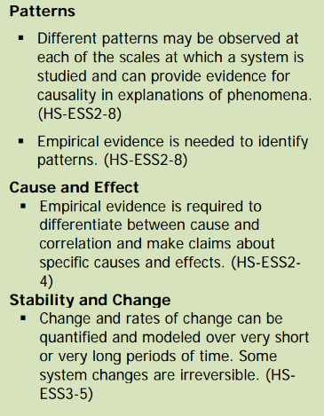
Performance Level
NYS Level 5 | NYS Level 4 |  |  | NYS Level 3 |  | NYS Level 2 |  | NYS Level 1
Collect and analyze global and regional weather data using tools, technologies, and /or models to communicate in multiple formats how the movement and interactions of airmasses result in changes in weather conditions. | Evaluate data and communicate information to explain how the movement and interactions of air masses result in changes in weather conditions |  |  | Evaluate data and communicate information to identify patterns of movement and/or the resulting changes in weather conditions. |  | Use data to identify the patterns of movement or the interactions of air masses and the resulting change in weather conditions  or to identify factors that drive the movement of air masses or from given weather conditions, identify evidence from maps that support these conditions. |  | Use data and/or patterns of movement and interactions of air masses to identify the resulting changes in weather conditions or identify one factor that drives the movement of air masses or from those provided, use evidence from maps to account for weather conditions or given weather conditions, identify evidence found on maps that account for one of these conditions.
Clarification Statement  Examples of evidence sources could include station models, surface weather maps, satellite images, radar and accepted forecast models. Emphasis should focus on communicating how the uneven heating of the Earth’s surface at frontal boundaries and resulting weather phenomena. |  |  |  |  |  | Assessment Boundary  Analysis is limited to surface weather maps and general weather patterns associated with High and Low pressure systems
Connection to Anchoring Phenomenon:

Students will determine the 4 main weather variables (Temperature, Humidity, Wind and Air Pressure) by watching weather reports.

Students will then, over the course of seven days determine if the weather forecasts were accurate of not by comparing the forecast to the actual conditions.

Essential Question(s):

Have you ever watched a weather forecast and realized soon after that it was wrong?

What are the “things” that can change from day to day in the weather?

Was the data you collected accurate?

Instructional Strategies & Learning Tasks: Engage, Explore, Explain, Elaborate, Evaluate
Engage: Anchoring phenomenon, demonstration; observations of images, video clip or data… |  | Teacher will present several instances where weather reports have been wrong.
Explore: Students investigate, experiment, hands-on activity…. |  | Students will watch several weather reports and note items that can change from day to day.  Students will also look at weather forecasts for a 7 day period and compare the forecast to the actual conditions.
Explain: Students share their observations and evidence to explain their understanding…possible whole group/class discussion… |  | Class will discuss items (variables) that can change on a daily basis  Students will share their weather data that was collected and discuss if it matched the actual weather conditions  Teacher will introduce the term weather variable and the 4 main weather variables (Temperate, Humidity, Air pressure, Wind)
Elaborate: Students apply the science concepts they’ve just learned… |  | By collecting Weather data over 7 days and comparing the accuracy of the forecast
Evaluate (Formative Assessment): Student learning is evaluated. |  | Students will be evaluated based on the answers to teacher questions as well as a quiz and test

Copy and paste student worksheets below:

Student weather forecast data collection worksheet

